AWS Task-4

Task Description:

Launch an EC2 instance (Linux and Windows) along with a web server. Then, create an EBS volume of 5 GB, attach it to an EC2 machine (Linux and Windows), and take a snapshot. Finally, create an EBS volume using the taken snapshot.

Step 1:

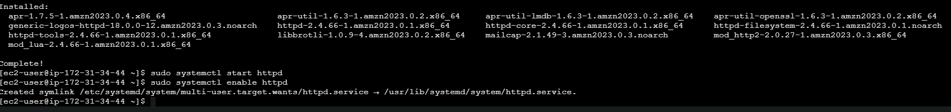

Step 2:

Step 3:

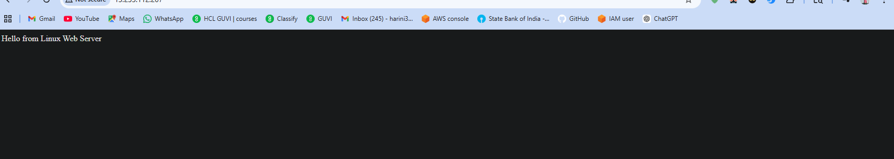

Step 4:

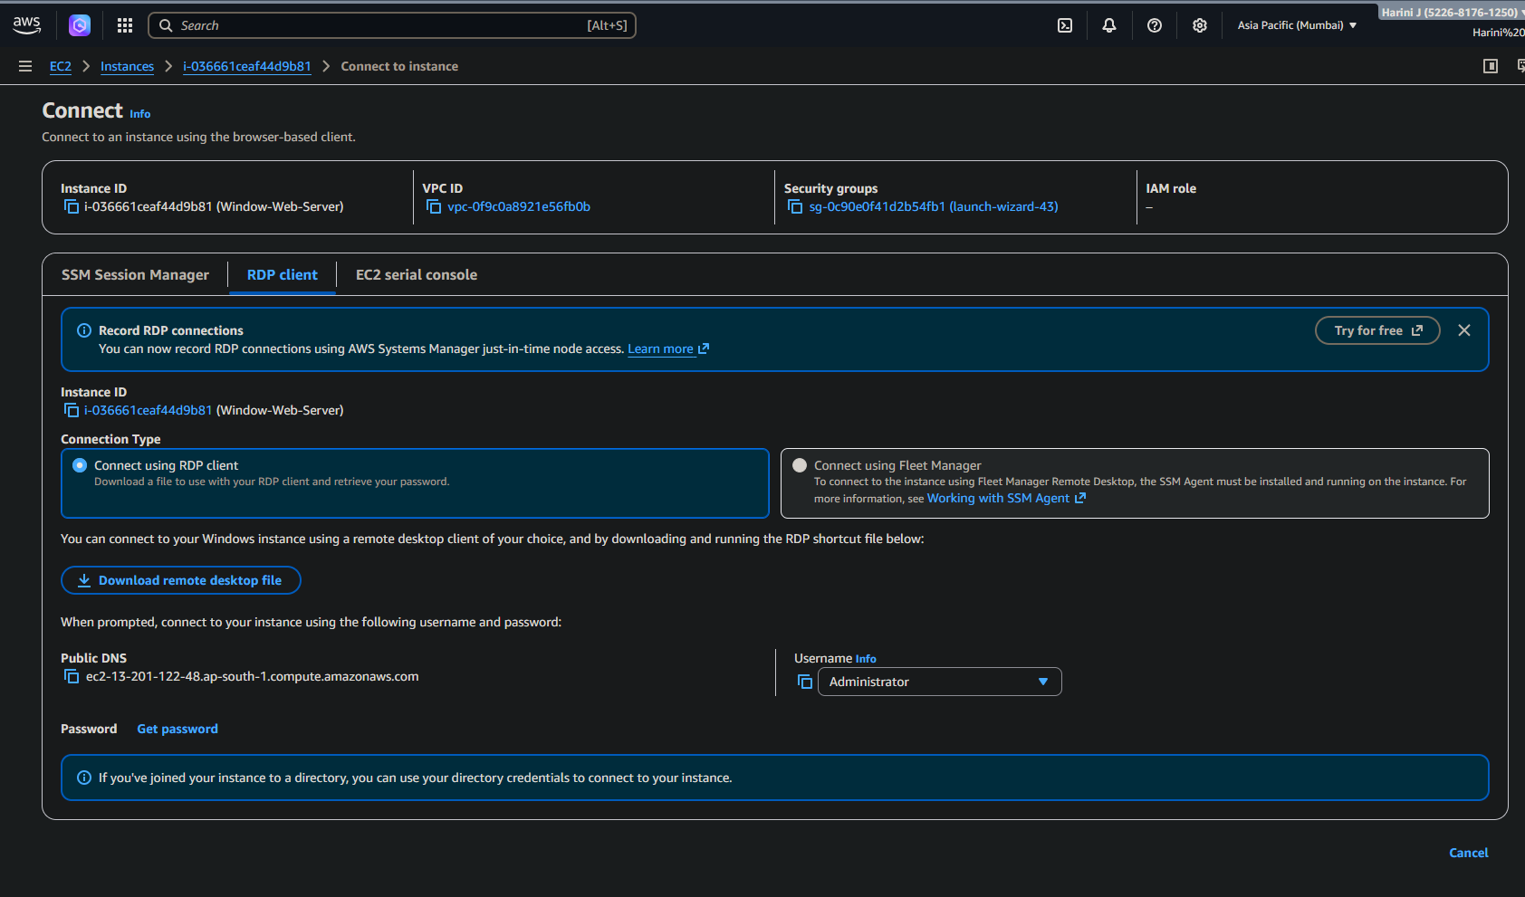

Step 5:

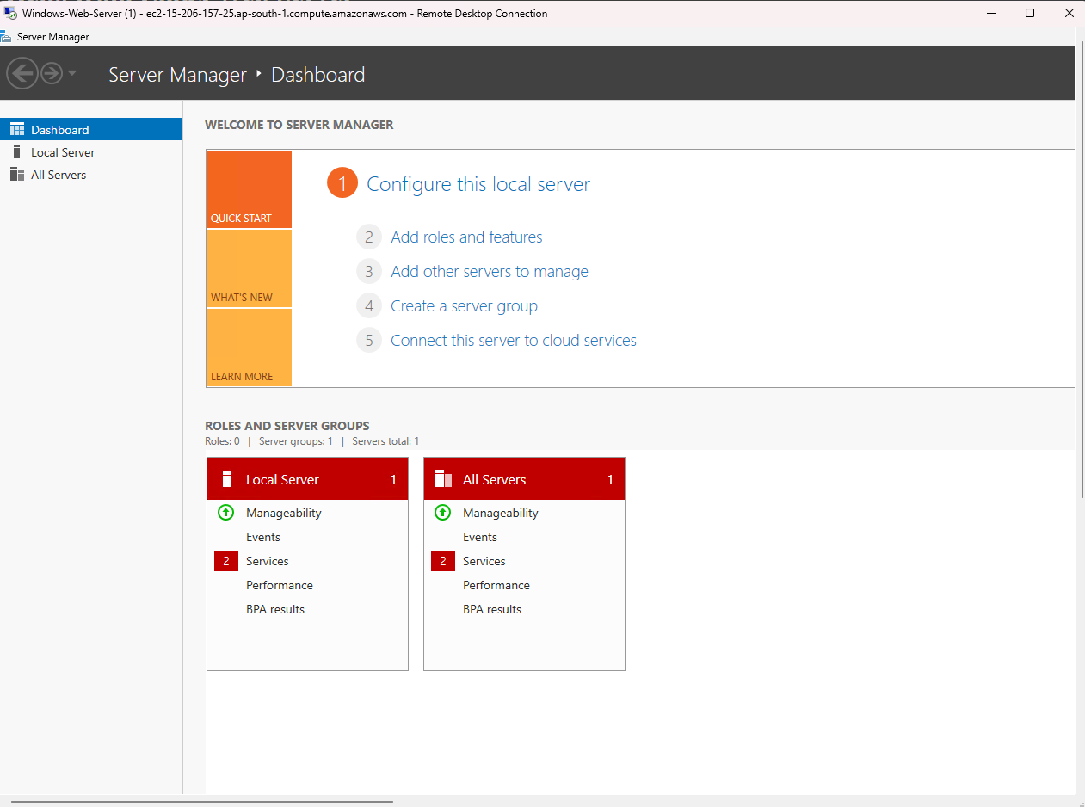

Step 6:

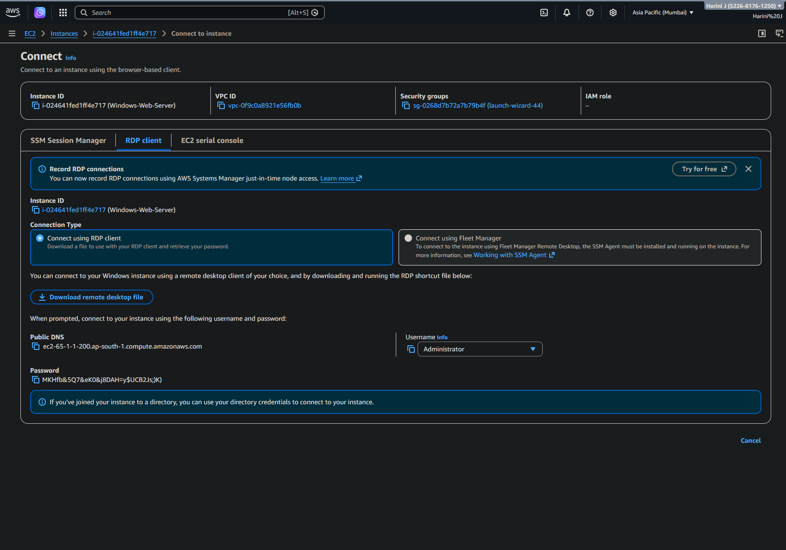

Step 7:

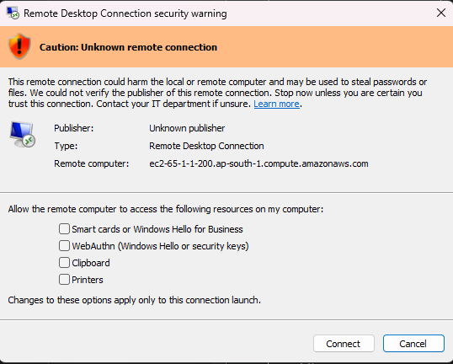

Step 8:

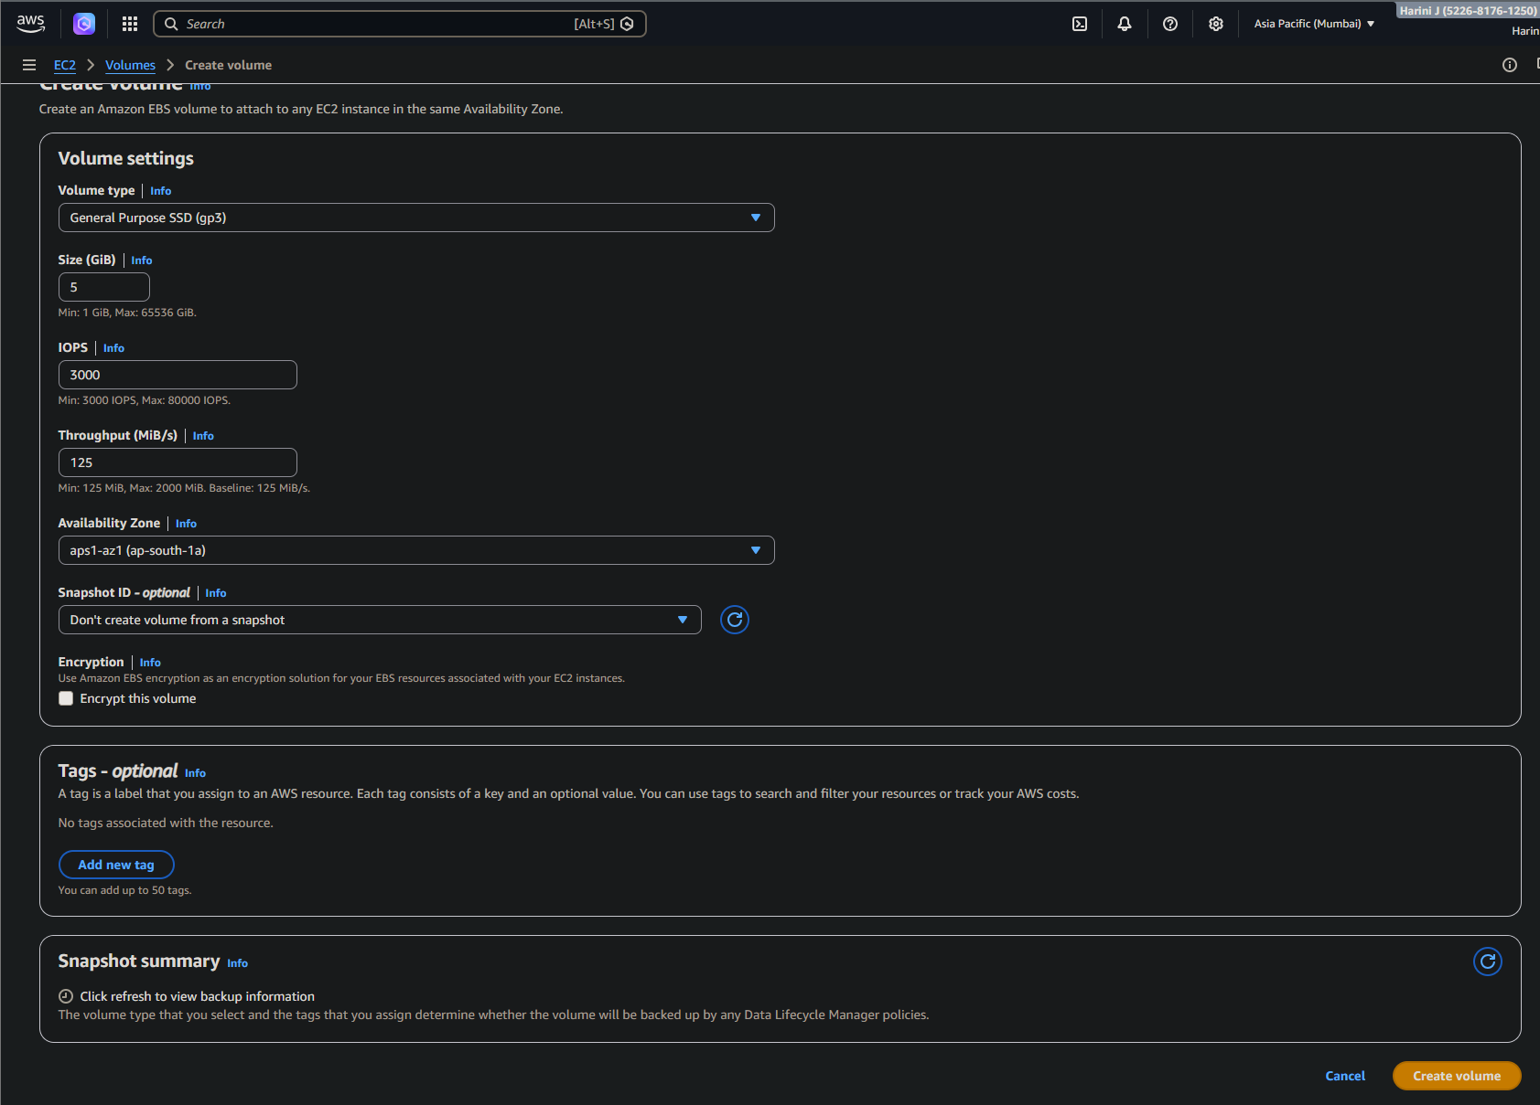

Step 9:

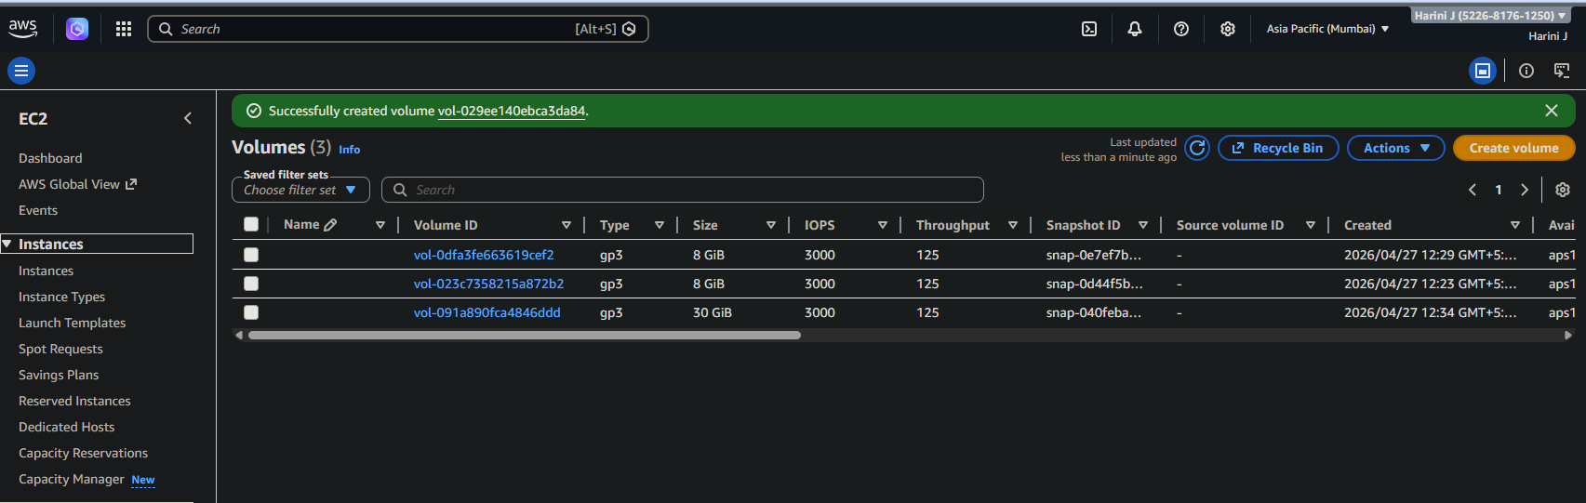

Step 10:

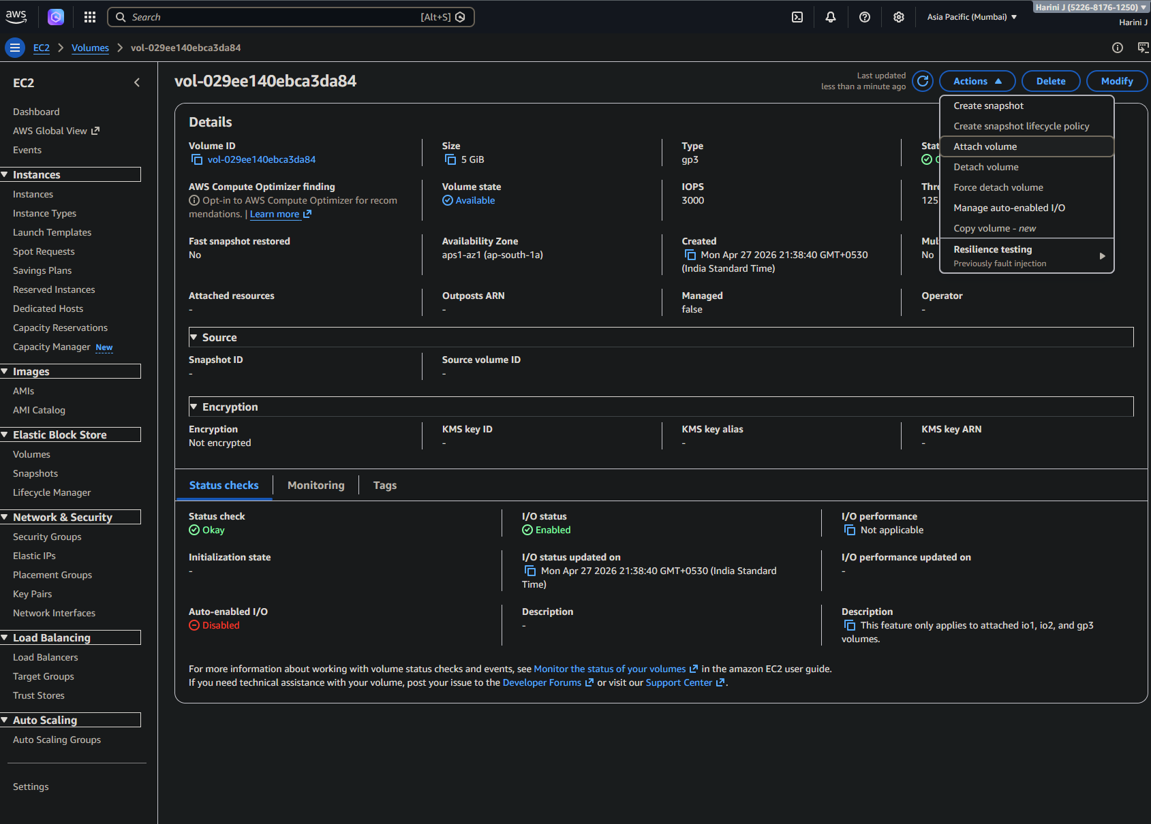

Step 11:

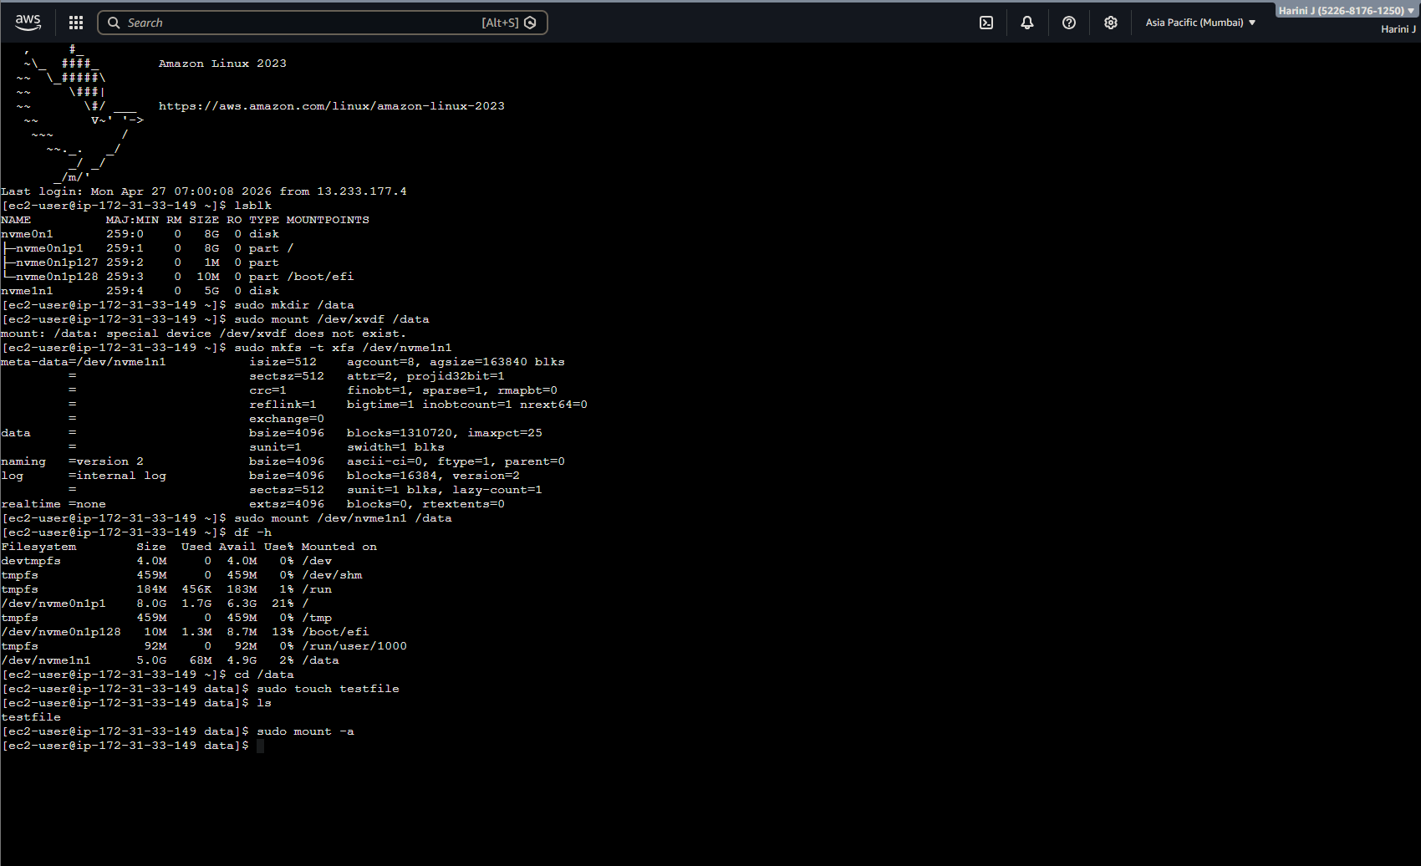

Step 12:

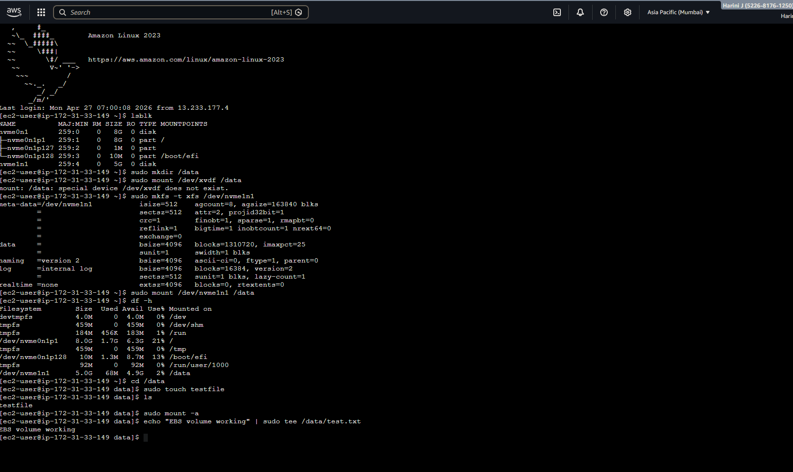

Step 13:

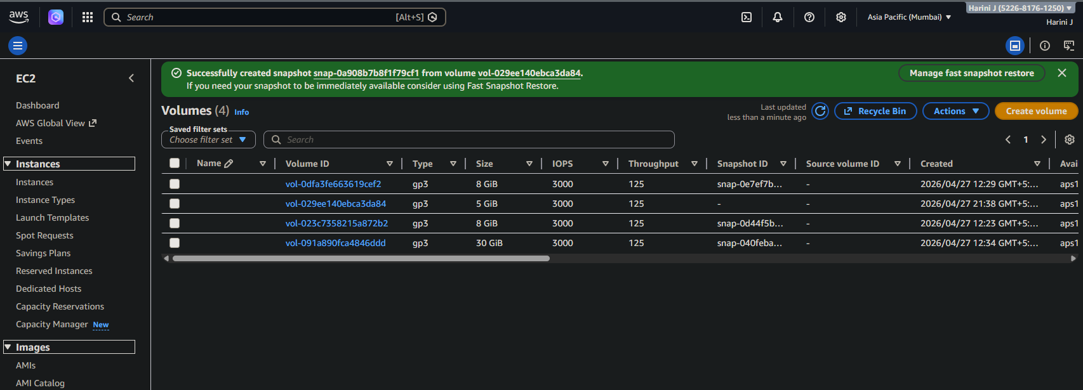

Step 14:

